HCOD DAY- 4

Problem Question (given):
The following problem is to find the product of two integers without using the multiplication operator *. Your teacher has given an incorrect algorithm and an incorrect flowchart for this problem (Refer SlideShare). Study both carefully and complete the tasks given below. [Hint: Use repeated addition]
Requirements:
The logic must use the minimum possible number of additions and should correctly handle:
• positive × positive
• positive × negative
• negative × positive
• negative × negative
• multiplication by zero
Given Incorrect Algorithm:
1. Define num1, num2, prod, index as integers
2. Get num1, num2
3. Set prod = 0, index = 1
4. Repeat steps 4.1 and 4.2 until (index <= num2)
4.1. prod = prod + num1
4.2. index = index + 1
5. Print prod
6. Stop
Errors identified:
1. Negative numbers are not handled:
The loop condition index <= num2 works only when num2 is positive. If num2 is negative, the loop does not run and the answer becomes 0.
2. Wrong number of additions:
The algorithm always adds num1 num2 times. It should use the smaller number to reduce the number of additions. For example, for 3 × 12, it should add only 3 times, not 12 times.
3. Zero is not handled separately:
The algorithm does not have a proper condition for when one of the numbers is 0. It should directly return 0 in that case.
4. Index is compared incorrectly:
The index starts from 1 and is compared directly with num2. This causes problems when num2 is negative or when num2 is smaller than num1
Corrected Algorithm
1. Define num1, num2, prod, index, absNum1, absNum2 as integers
2. Get num1, num2
3. absNum1 = |num1|, absNum2 = |num2|
4. Set prod = 0
5. If absNum1 < absNum2:
5.1. index = 0
5.2. Repeat while (index < absNum1): prod = prod + num2; index = index + 1
5.3. If num1 < 0: prod = -prod
6. Else:
6.1. index = 0
6.2. Repeat while (index < absNum2): prod = prod + num1; index = index + 1
6.3. If num2 < 0: prod = -prod
7. Print prod
8. Stop

Why This Works
The algorithm uses the smaller absolute value, so it needs fewer additions and works faster.Using absolute values makes it easier to handle positive and negative numbers. After the multiplication is done, the sign is changed only if one of the original numbers is negative.If either number is 0, the loop does not run, so prod remains 0, which gives the correct answer.
START
stop
Print prod
Index = 0
Index = 0
If absNum1 < absNum2 ?
Set prod = 0
absNum1 = |num1|, absNum2 = |num2|

ab
Get num1, num2
Define num1, num2, prod, index, absNum1, absNum2
Prod=prod+num1
Index=index+1
prod=prod+ num2
index= index + 1
If num2<0;
Prod=-prod
If num1<0;
Prod=-prod

Index< absNum2 ?
Index < absNum1 ?
C Implementation:
The corrected algorithm implemented is

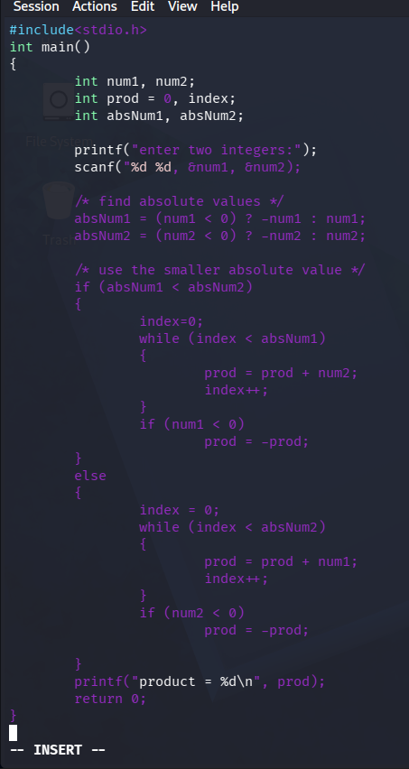

Verification Against Test Cases:
The corrected algorithm and code were traced/run against all test cases specified in the assignment. All 13 cases produce the expected output using the minimum number of additions.
Test cases | Input (num1, num2) | Expected output | Min. additions | result
1 | 12,3 | Product:36 | 3 | pass
2 | 3,12 | Product:36 | 3 | Pass
3 | -6,5 | Product: -30 | 5 | Pass
4 | 6, -5 | Product: -30 | 5 | Pass
5 | -9, -4 | Product:36 | 4 | Pass
6 | -4, -9 | Product:36 | 4 | Pass
7 | 0,8 | Product:0 | 0 | Pass
8 | 8,0 | Product:0 | 0 | pass
9 | 0, -7 | Product:0 | 0 | Pass
10 | -7,0 | Product:0 | 0 | Pass
11 | 0,0 | Product:0 | 0 | Pass
12 | 1, -7 | Product: -7 | 1 | Pass
13 | -1, -9 | Product:9 | 1 | pass

Conclusion
The original algorithm was unable to produce correct results when the second number was negative and did not minimize the number of additions required. The improved algorithm overcomes these issues by performing repeated addition based on the smaller absolute value of the two inputs and adjusting the sign only after the calculation is complete. As a result, it correctly handles all possible cases, including positive and negative combinations as well as multiplication by zero, while ensuring the minimum number of additions. The correctness of the algorithm was confirmed by testing it with all 13 test cases provided in the assignment.

